FORM A5 — OUTSOURCING DECLARATION & REGISTER
(Issued under Regulation 14 of the No Obejction Certificate Regulations 2025)
This Form must be completed by the Compliance Officer of the Applicant.
It must disclose all outsourcing arrangements that relate to AML/CFT obligations.
SECTION A — APPLICANT DECLARATION
The Applicant confirms that:
1. It has identified all outsourced functions that support or impact AML/CFT obligations.
2. All outsourcing arrangements comply with Regulation 14 of the No Objection Certificate Regulations.
3. The Applicant retains full responsibility and oversight for all outsourced functions.
4. All outsourcing contracts include:
o appropriate service levels;
o data protection and confidentiality clauses;
o audit and inspection rights for the Applicant and PVARA;
o termination rights;
o controls to prevent unauthorised sub-outsourcing.
5. No outsourcing arrangement prevents or restricts the Applicant from complying with AMLA 2010, PVARA Regulations or FMU reporting requirements.
SECTION B — OUTSOURCING REGISTER
Complete one line for each outsourced service relevant to AML/CFT.
Attach additional pages if required.

No. | Item | Information Required
1. | Service Provider Name | Jumio Corporation
2. | Country of Incorporation / Operation | United States
3. | Function Outsourced | KYC verification
4. | AML/CFT Relevance | ID verification
5. | Data Shared With Provider | KYC data
6. | SLA Summary | At least 99.5% of the time over the course of a calendar month to accept Transactions.  Fastfill - The eightieth percentile of all transactions performed in the relevant month, is less than 7 seconds and the ninety-fifth percentile of all transactions performed in the relevant month, is less than 10 seconds.  BAM Checkout - The eightieth percentile of all transactions performed in the relevant month, is less than 7 seconds and the ninety-fifth percentile of all transactions performed in the relevant month, is less than 10 seconds.  ID verification - The eightieth percentile of all transaction performed in the relevant month, is less than 150 seconds and the ninety-fifth percentile of all transaction performed in the relevant month, is less than 270 seconds; provided that all of the ID verification scan times referred to above shall be increased by (i) 40 seconds when the identity verification feature is used; and (ii) forty seconds when the address extraction feature is used.  Document verification – the ninety-fifth percentile of all transactions performed in the relevant month, is less than 60 minutes.  Authentication – the eightieth percentile of all transaction performed in the relevant month, is less than 7 seconds and the ninety fifth percentile of all transactions performed in the relevant month, is less than 10 seconds.
7. | Audit Rights | ✓ Yes □ No
8. | Sub-Outsourcing Permitted | □ Yes ✓ No
9. | Termination Rights | ✓ Standard □ Enhanced □ None
10. | Risk Assessment Summary | Low as HTX Group has been engaged with Jumio for a number of years and the cooperation is very smooth.
11. | Monitoring Frequency | □ Monthly □ Quarterly ✓ Annually

No. | Item | Information Required
1. | Service Provider Name | Factiva Limited (affiliated company of Dow Jones)
2. | Country of Incorporation / Operation | UK
3. | Function Outsourced | CDD
4. | AML/CFT Relevance | Name screening and sanction screening
5. | Data Shared With Provider | No client data shared. We only subscribe for their watchlist database.
6. | SLA Summary | Dow Jones support team operates in a follow-the-sun model with 24x7 coverage and is available 363 days per year (closed on Christmas and New Year’s Day).  Customer Service Initial Response Time Objectives:  - Live chat with an experienced customer service executive within 30 seconds (closed on Christmas and New Year’s Day)  - Login queries addressed within 10 minutes (1 hour on weekends)  - Email response within 4 hours (closed on Christmas and New Year’s Day).  - Country-specific phone lines answered within 30 seconds (weekdays only)  Escalated Issue Response Times (based on the time Customer Service escalated the issue):  Severity Level 1 (P1) - if a Dow Jones Risk & Compliance service is completely unavailable: An initial update on the status of the P1 incident will be shared via the subscribed alerts within 60 minutes during the business week and 120 minutes on weekends (should the incident remain unresolved in that timeframe.)  Severity Level 2 (P2) - if a Dow Jones Risk & Compliance service is available, but a critical component of that service is unavailable: An initial update on the status of the P2 incident will be shared via the subscribed alerts within 120 minutes during weekdays.
7. | Audit Rights | ✓ Yes □ No
8. | Sub-Outsourcing Permitted | □ Yes ✓ No
9. | Termination Rights | ✓ Standard □ Enhanced □ None
10. | Risk Assessment Summary | Low as HTX Group has been engaged with the vendor for a number of years and the cooperation is very smooth.
11. | Monitoring Frequency | □ Monthly □ Quarterly ✓ Annually

No. | Item | Information Required
1. | Service Provider Name | Chainalysis Inc.
2. | Country of Incorporation / Operation | US
3. | Function Outsourced | blockchain analytics and  transaction monitoring
4. | AML/CFT Relevance | an on-chain transaction monitoring tool that will detect and report movements of supported crypto-assets to and/or from addresses or clusters of addresses known to be associated with financial crimes
5. | Data Shared With Provider | wallet addresses, transaction logs
6. | SLA Summary | Services will be available 99% of the time, measured monthly.  For very serious incident affecting all services, the response time is 2 business hours.  Serious degradation of application performance or functionality, 4 business hours.  Moderate impact to the business, 8 business hours.  Limited business impact, 16 business hours.
7. | Audit Rights | ✓ Yes □ No
8. | Sub-Outsourcing Permitted | □ Yes ✓ No
9. | Termination Rights | ✓ Standard □ Enhanced □ None
10. | Risk Assessment Summary | Low as HTX Group has been engaged with the vendor for a number of years and the cooperation is very smooth.
11. | Monitoring Frequency | □ Monthly □ Quarterly ✓ Annually

No. | Item | Information Required
1. | Service Provider Name | VerifyVASP Pte. Ltd.
2. | Country of Incorporation / Operation | Singapore
3. | Function Outsourced | Travel Rule Solution
4. | AML/CFT Relevance | Travel Rule Solution
5. | Data Shared With Provider | KYC data, wallet addresses, logs
6. | SLA Summary | Services will be available 99.9% of the time, measured monthly.  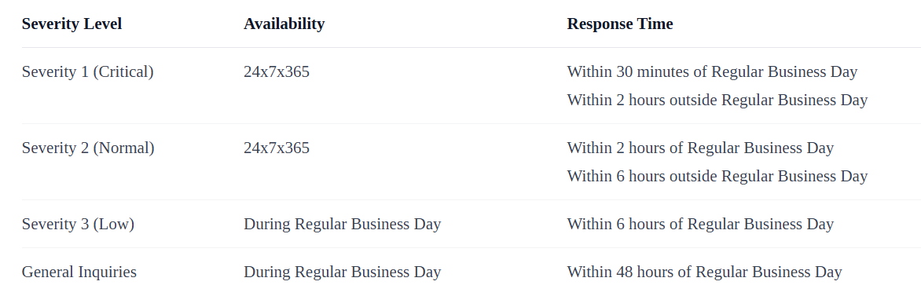
7. | Audit Rights | ✓ Yes □ No
8. | Sub-Outsourcing Permitted | □ Yes ✓ No
9. | Termination Rights | □ Standard □ Enhanced □ None
10. | Risk Assessment Summary | Low as HTX Group has been engaged with the vendor for a number of years and the cooperation is very smooth.
11. | Monitoring Frequency | □ Monthly □ Quarterly ✓ Annually

No. | Item | Information Required
1. | Service Provider Name | CODE Inc.
2. | Country of Incorporation / Operation | South Korea
3. | Function Outsourced | Travel Rule Solution
4. | AML/CFT Relevance | Travel Rule Solution
5. | Data Shared With Provider | KYC data, wallet addresses, logs
6. | SLA Summary | 24/7 Communication and technical support
7. | Audit Rights | ✓ Yes □ No
8. | Sub-Outsourcing Permitted | □ Yes ✓ No
9. | Termination Rights | □ Standard □ Enhanced □ None
10. | Risk Assessment Summary | Low as HTX Group has been engaged with the vendor for a number of years and the cooperation is very smooth.
11. | Monitoring Frequency | □ Monthly □ Quarterly ✓ Annually

Repeat this table for each outsourced function.
SECTION C — COMPLIANCE OFFICER SIGNATURE
I, the undersigned Compliance Officer, declare that:
• the information provided in this Form is true, complete and accurate;
• all AML-relevant outsourcing arrangements have been disclosed;
• all outsourcing complies with the No Objection Certificate Regulations;
• the Applicant remains fully accountable for AML/CFT compliance.

Signature: _______________Qin Yuqing_______________
Full Name: ________Qin Yuqing_____________________
Date: ________11 Dec 2025__________________________
___________________________________

